

Qualification guidance (including exams) for pupils and parents

2025-26

At Foundry, we know that the time leading up to exams and other external qualifications can be stressful and we would like to reassure you as much as possible about the process. We hope that giving you this information will give you plenty of time to ask any questions you have or seek any reassurance that you needed. Remember, all your teachers are there to support you through this process so please ask for any help that you need.

If you or your parents/carers have any questions or need any help or advice before, during or after exam, please contact your tutor in the first instance.

For exam specific queries please liaise with Anna Wicks (Exams Officer)

[exams@foundry.wokingham.sch.uk](mailto:exams@foundry.wokingham.sch.uk)

Remember - we are all here to help and support you.

**Contents**

|  |  |
| --- | --- |
| Wellbeing during the exam period | 3 |
| Coursework | 4 |
| **Before the Exams** | 4 |
| Entries and Timetables | 4 |
| Exam entries and preferred names | 4 |
| Access Arrangements | 4 |
| Mock Exams | 5 |
| **Exam Days** | 5 |
| Illness/Injury | 5 |
| Special Consideration | 5 |
| Late Arrival to Exam | 5 |
| Exams Equipment | 5 |
| Food and Drink in exams | 6 |
| Malpractice | 6 |
| Unauthorised items | 7 |
| During the Exam | 7 |
| End of the exam | 7 |
| **After Exams** | 8 |
| Results | 8 |
| Certificates | 8 |
| JCQ Information for Candidates *Appendix 1* | 11 |

**Wellbeing during the exam period**

Exam success is all about balance. Of course, revising plays a huge part in how you do, but so does switching off and self-care.

|  |
| --- |
| * Make time for things you enjoy. * Connect with other people about how you feel. * Take regular breaks and be realistic about what you can do in a day. * Take care of your physical health. Make sure you get enough sleep, food, water and exercise. * Focus on yourself. Try not to compare yourself to others.   More information can be found - <https://bit.ly/3x5kpe7> |

**Exam stress can be difficult to cope with.**

If you notice that you are struggling and it all feels overwhelming, find someone that you trust to talk to about how you are feeling.

Exam results do not define who you are and there are many different routes you can take to achieve your goals.

Dr Sheila Redfern gives advice and tips on managing stress at important moments

<https://youtu.be/VGqDAUZwhas>

Useful information and resources and where to get further support:

<https://www.mind.org.uk/for-young-people/feelings-and-experiences/exam-stress/>

<https://www.youngminds.org.uk/young-person/coping-with-life/exam-stress/>

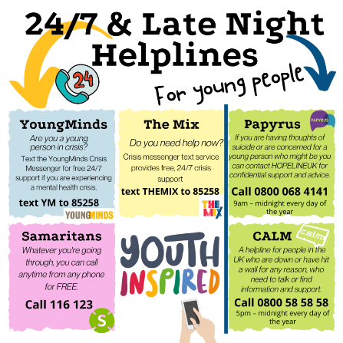The evening before an exam is important. Remember there is always, always someone to speak to.

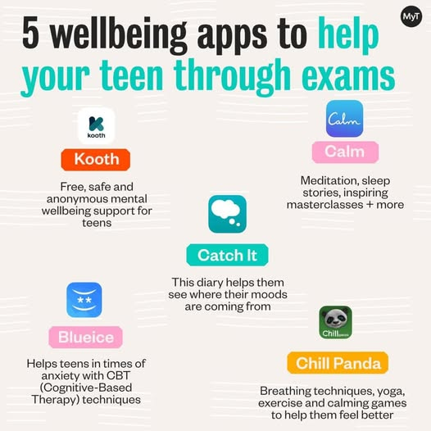

**Coursework/Non-examination Assessment**

Some of our qualifications are assessed on coursework only or a combination of coursework and exam.

Coursework and other assessed work completed outside of the exam process is known as ‘Non-examination Assessment (NEA)’. Your teachers will share your provisional marks with you for any NEA. If you are not happy with the mark you have been awarded there is an internal appeals process.

You will be able to claim your coursework approximately three months after you receive your results or at our certificate presentation evening.

**Before the Exams**

**Entries and Timetables**

**The summer exam period in 2026 will run from the 7th May to the 17th June**

You will receive your personal exam timetable in April showing you when you will sit exams for each subject. This will include the date, start time and duration of the exam.

When you receive your individual exam timetable, **please check it carefully**. If there are any mistakes (eg name, date of birth, exam entries, etc) you must inform the Exams Officer (Anna Wicks) immediately.

**Contingency days** – JCQ have contingency sessions in place in the event of national or significant disruption to examinations in the UK.

This year the contingency date is set for the 24th June.

This means that whilst there are currently no exams scheduled for this date, all candidates must be available on this day.

**Exam entries and preferred names**

At Foundry, pupils are registered for exams using their legal name (as shown on their birth certificate) as qualification certificates are also a legal document.

In exceptional circumstances exam entries can be made in preferred names however there is a charge to change the name shown on the certificate should you wish to change it in the future.

**Access Arrangements**

Some pupils are entitled to adjustments to make sure they have an equal chance of completing the exam papers. In all cases, regardless of any medical condition or diagnosis of need it must reflect the candidate’s normal way of working.

Our Access Arrangements coordinator, Kirsty Flaws, will talk to you and complete some assessments. If there is evidence of need and teachers support the findings access arrangements can be applied for. Please note that if these do not continue to reflect the pupil’s normal way of working they may be removed.

**Exam Days**

You should be at the College/provision at least 15 minutes before your exam start time so that you are not in a rush before your exam. Staff will be available to make you a drink and answer any question you may have. You need to go to your exam room 5 minutes before your exam is due to start.

**What to do if you are ill/injured**

Please contact Foundry as soon as possible to let us know. There are arrangements that we can make to help you take your exam if you are able to.

It is not possible to move GCSE exams, however we may be able to make a special consideration application on your behalf dependent on the reason and evidence for absence. These applications can be made if you either a) attend the exam but were disadvantaged because of your illness or b) cannot attend at all.

**Special Consideration**

Special consideration is a post-exam adjustment to a candidate’s mark to reflect temporary illness, injury or other indisposition at the time of the assessment. You should be aware that any adjustment for special consideration is likely to be small and no feedback is provided. Candidates are only eligible if they have been fully prepared for the assessment but have been affected by adverse circumstances beyond their control. Examples of such circumstances may be illness, accident or injury, bereavement or domestic crisis at the time of the examination/assessment/ The Exams Officer must be informed immediately so that the necessary paperwork can be completed and the candidate will be required to provide evidence to support such an application.

You must attend all exams that are allocated to you on your individual

candidate timetable. Misreading the timetable will not be accepted as

a satisfactory explanation for your absence. You will be required to pay

the entry fee for any exam you fail to attend. If you miss an

examination due to illness, you **must** telephone the school on (01252)

615065 as soon as possible on the morning of the exam, **and** a medical

certificate/letter MUST be given/sent to the Exams Officer within

**Late Arrival to Exam**

If for any reason you are going to be late and will miss the start of the exam you **MUST** telephone the College as soon as possible. If you are late arriving, you will still be able to sit the paper and you will still be allowed the full time for the exam.

If you start your exam more than 30 minutes after the published start time, we have to inform the awarding body who will decide if they wish to apply a late arrival penalty, such as removing marks or not marking the paper at all.

**Exams Equipment**

**We will provide the equipment you need for each exam** however some pupils may prefer to use their own equipment.

All equipment must be in a **clear plastic bag or transparent pencil case** so the invigilator can see what is inside.

You will need the following:

* A clear pencil case
* At least 2 **black** pens (no gel pens or erasable pens)
* 2 pencils
* A 30cm ruler
* Pencil sharpener
* A pencil eraser (with any cardboard label removed)

For certain exams you may also need the following –

* Pair of compasses
* Protractor
* Calculator (talk to the maths teachers or see exam board guidance about which calculators are permitted)
* Coloured pencils
* Highlighter (you can only use these on the question paper to highlight key words)

We will always have spares, so please don’t worry about anything running out as we will be able to provide you with an alternative.

**Food and Drink in exams**

Drinks, preferably water are allowed in the exam. Drinks must be in a clear, transparent bottle or glass with no labels on.

Food is not permitted in the exam room.

**Malpractice**

Malpractice isn’t just cheating/copying – it includes bringing unauthorised items in to the exam room, disrupting or trying to disrupt or communicate with other candidates, taking exam material from the exam room etc.

The penalties for committing malpractice can vary from a written warning to being disqualified from all exams with an awarding body.

Link to the JCQ Information for Candidates - <https://www.jcq.org.uk/exams-office/information-for-candidates-documents/>

It is the pupil’s responsibility to read and understand the JCQ’s Information for Candidates. Your tutors and subject teachers will also go through it with you. Please ask if you do not understand anything.

**What you can’t take into an exam room - unauthorised items**

You cannot have the following with you in the exam room:

* Your mobile phone (you must hand this in and it must be switched off)
* A watch (including digital, analogue or smart watches)
* Any device capable of connecting to the internet (eg smart glasses, organisers, other electronic communication or storage devices)
* An iPod or MP3/4 player
* Air pods or earphones/ear buds
* Notes or paper for ‘doodling’ on
* Any pencil case/water bottle/snack packaging or bag that is not transparent.
* Calculator cases and instruction booklets.

If any of these items are found once the exam has started it will be reported as malpractice and you may be subject to a penalty or disqualification.

**During the exam**

Listen carefully to the instructions given by the invigilator at the beginning of the exam.

Complete all exam papers in black pen, unless the paper says you can use a pencil for diagrams.

Do not draw graffiti or use bad language on your exam papers – they are not looked at by Foundry College staff before they are sent to awarding bodies and the awarding body may refuse to accept and mark your paper.

**Conduct in the Exam Room** – You must be silent at all times when you are in a shared exam room. This includes when you enter and leave (remember other people may still be working on their exam nearby). If you need help, put your hand up to attract the invigilator. Once you have entered the exam room, you have to remain under centre supervision until the exam has finished or until the first hour has passed should you complete the exam sooner than the published end time.

**End of the exam**

Try to give yourself time to read through your exam paper to make sure you haven’t missed any questions or there isn’t more information you could add.

If you have finished before the official exam time ends let your invigilator know and you will be supported to leave the exam room early. **All candidates must remain in the exam room under exam conditions (ie no electronic devices) for the first hour of the exam.**

**After Exams**

**Results**

Functional skills exams –We receive these results back from the boards within 28 days of the exams. You will receive a letter informing you of the results and your subject teacher will also discuss them with you.

Vocational qualifications – We moderate your coursework throughout the year internally. When you have completed the units required for your qualification these also need to be externally moderated and then your result will be confirmed. This usually happens at the end of the Summer Term and results will be communicated to you.

GCSE results - Results will be issued to you on 20th August 2026. Pupils will be invited in to collect their results from the College. Pupils who cannot attend to collect their results will need to send their written permission to the exams officer to have the results either sent directly to them or to a parent/carer if they are collecting on their behalf.

If you need any advice about any of your results, you will be able to discuss this with the Next Steps lead/SLT on results day if they relate to GCSEs. All other results can be discussed as they are released. Information on post results services (review of marking, appeals etc) will also be issued closer to exam time and is on the website (Enquiries about Results Guidance).

**Certificates**

Certificates arrive at Foundry College two to three months after you have received your results. We hold a Certificate Presentation Evening (usually at the beginning of December). If you are not able to attend we can arrange for your certificates to be collected by you or your representative at a different time.

The JCQ Information for Candidate (Coursework, Non-Examination Assessment, Written Exams, On Screen Tests and Social Media) can be accessed via the Foundry website or at [Information for candidates documents - JCQ Joint Council for Qualifications](https://www.jcq.org.uk/exams-office/information-for-candidates-documents/)

**Appendix 1 - JCQ Privacy Notice (2024-25)**

[Information-for-candidates-Privacy-Notice-10.doc.pdf](https://www.jcq.org.uk/wp-content/uploads/2020/01/Information-for-candidates-Privacy-Notice-10.doc.pdf)

