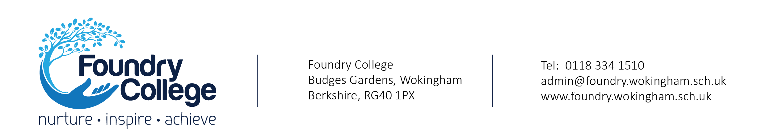

TUTORS

SALARY RANGE: MPR Point 6

CASUAL or 5hrs PER WEEK CONTRACT

Flexible start dates

Foundry College is a ‘Good’ Pupil Referral Unit in the heart of the community of Wokingham supporting the young people, schools and families in the area. Our dedicated staff offer a range of educational, emotional and behaviour support, with bespoke packages for our students aged 5 - 16.
As Foundry College develops, we are looking to recruit a number of highly motivated, outstanding Tutors into our Home Tuition Team, who really want to make a difference to the young people. Covering a range of subjects across all Key Stages, these are key roles which help to develop a safe, respectful learning environment within the College.
The ideal candidate will:
- Be an experienced, effective and versatile practitioner
- Be an outstanding teacher, with high expectations of learning and behaviour
- Have a commitment to push pupils to achieve beyond their expected progress levels
- Have a passion for building strong relationships with young people through restorative working
- Be someone who is resilient and approachable
- Be a good communicator who is able to inspire and motivate pupils but who can remain calm under pressure and has a sense of humour
- Be creative in teaching strategies and strive to bring out the best in pupils
In return, we can offer you:
- A professional development programme
- A friendly and supportive staff team, dedicated to improving pupil outcomes and life chances
- A Senior Leadership Team that encourages team working, innovation and the use of solution based thinking
The pupils, staff and Management Committee warmly invite you to visit us and see the ‘Foundry Family’ in action. You will experience our friendly, relaxed atmosphere and get a taste of how rewarding your work will be. Please contact Dionne Wyatt on 0118 334 1510 to arrange a mutually convenient time.
To apply, please visit our website Teaching Vacancies | Foundry College
Completed Application Forms should be emailed to recruitment@foundry.wokingham.sch.uk.
Interview date: To be arranged as and when applications are received
Foundry College is fully committed to safeguarding and to promoting the welfare of children and young people.
This position requires an enhanced DBS disclosure
CVs will not be accepted

